**Advance Excel Assignment 5**

1. **How many types of conditions are available in conditional formatting on Excel**?

**Ans**: [**Conditional Formatting**](https://www.exceldemy.com/excel-conditional-formatting-on-multiple-columns/) is a must-be-used feature of [**Microsoft Excel**](https://www.microsoft.com/en-us/microsoft-365/excel) for better statistical analysis and visualization of data. This feature is mainly used for highlighting cells in a data set based on different conditions.   
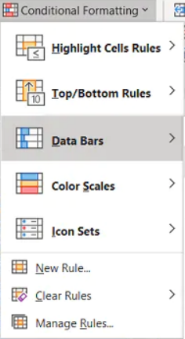

Here are different types of conditional formatting in Excel. Several conditional formatting is as follows:

* The first type of [**conditional formatting in Excel**](https://www.exceldemy.com/how-to-do-conditional-formatting-in-excel/) is the **Highlight Cells Rules**. Under this type, we will give some specific conditions, and the presentation of the cells will change upon these conditions.
* **Icon sets** are exactly what you’re thinking — small images we can use to organize our data — and it’s super easy to use them in Excel with conditional formatting.
* Another way to display conditional formatting in your data is with **data bars**. If you highlight a column and apply data bars, you'll see that they appear in the column. Using this method, it’s easy to visualize your data relative to other values: the bigger the data bar, the bigger the value. You also have a choice between using a gradient or a solid color bar in your visualization.
* **Top/bottom rules** are another cool way to use conditional formatting. This allows you to organize your data based on the highest or lowest values in your data set. From there, you can further hone your data set by focusing on the values you care about most.
* [**Color Scales**](https://www.exceldemy.com/excel-conditional-formatting-color-scale-per-row/) display the disposal of data in the data set. You can mix two colors or three colors on the scale. The topmost color will represent the **greater values**, the middle scale will represent the average values, and the bottom color scale will represent the lower values in a data set.

1. **How to insert border in Excel with Format Cells dialog?**

**Ans**: To insert a border via the *Format Cells* dialog, this is what you need to do:

1. Select one or more cells to which you'd like to add borders.
2. Open the *Format Cells* dialog box by doing one of the following:
   * Click the down arrow next to the *Borders* button, and then click **More Borders** at the bottom of the drop-down list.
   * Right-click the selected cells and choose *Format Cells…* from the context menu.
   * Press Ctrl+1 shortcut.  
     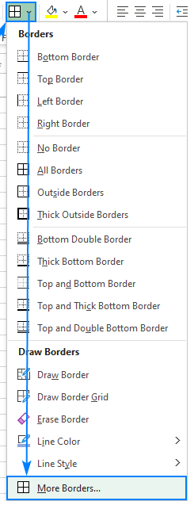

1. **How to Format Numbers as Currency in Excel?**

**Ans**: Here are two ways:

* 1. Right click-> format cells, then in Number tab, go to currency, select format and OK
  2. Ctrl + shift+4 ($)

1. What are the steps to format numbers in Excel with the Percent style?

**Ans**: Showing 2 ways,

* + 1. Right click on the cell, click Format cells, In Number Tab, click percentage, and OK
    2. On the ribbon, go to Home, in Number grouping, there is a % icon, click on that

1. **What is a shortcut to merge two or more cells in excel?**
2. **Ans**: Merge Cells ([Excel Shortcut key](https://www.wallstreetmojo.com/keyboard-shortcuts-excel/) – **ALT H+M+M**)
3. Merge & Center (Excel Shortcut key – **ALT H+M+C**)
4. Merge Across (Excel Shortcut key – **ALT H+M+A**)
5. Unmerge Cells (Excel Shortcut key – **ALT H+M+U**)

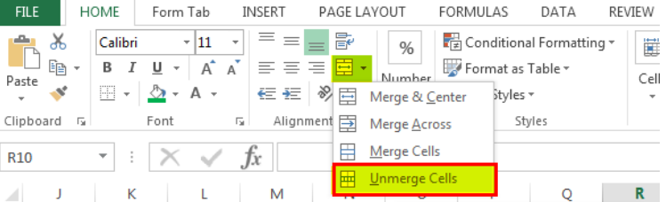

1. **How do you use text commands in Excel?**

**Ans**: Select the column, or range where you'll be putting the values, then use CTRL+1 to bring up the Format > Cells dialog and on the Number tab select Text.